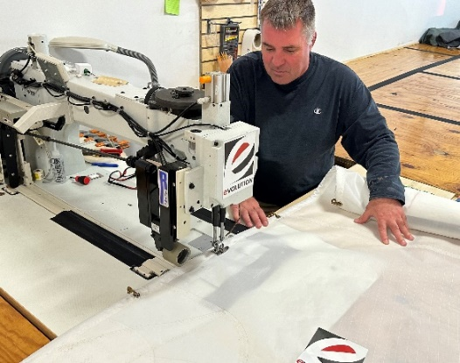
We are your official Sail Repair Source!

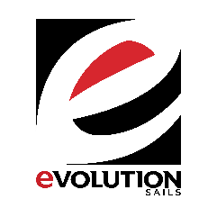
If you need sail repair work done during race week, please drop your sails with us at our Evolution Sails tent located at the northeast corner of the marina, between the College of Charleston Sailing Center and the Yorktown. Drop your damaged sails off by 5:15 with this card filled out with all your info and repairs needed and we’ll have it back by 8:15 the next morning!
Call any one of our staff with questions!
Matt Smith -843 817 4944 Sam Rosenbaum- 612 402 4006 Carl Eaton- 612 750 2691

SAIL REPAIR INFORMATION
Name____________________________________________ Phone______________________________________
Address__________________________________________ City_________________________________________
Zipcode_____________________________Email_____________________________________________________
Boat/Class________________________________ Name/Sail Number_________________________________
Sail_______________________________________ Repairs needed____________________________________
_______________________________________________________________________________________________
_______________________________________________________________________________________________
Estimate_______________________________Do you need call if repair is 20% more than est?_________

Draw diagram/notes regarding repairs on the back if needed.

Credit Card number___________________________________________________________Exp_____________CDC______
Billing address if different than above___________________________________________________________________________________________________________________________________________________________________________________________________

